
City of Moreno Valley
Community Development Department
Planning Division
City Hall Council Chamber
14177 Frederick Street
Moreno Valley, CA 92553

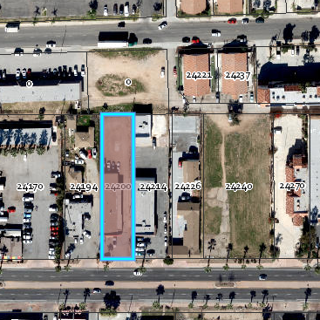
NOTICE OF PUBLIC HEARING
Notice of Public Hearing before the Planning Commission of the City of Moreno Valley for the following item(s):
Postal Ave
MEETING INFORMATION: January 9, 2020, 7:00 P.M.
Moreno Valley Council Chamber, 14177 Frederick Street
PROJECT LOCATION: 24200 Sunnymead Boulevard; north side of Sunnymead Boulevard, east of Heacock Street and west of Back Way (APN: 481-112-011), in District 1.
CASE NUMBER(s): PEN19-0053
SITE
CASE PLANNER: Jerry Guarracino, Contract Planner (951) 413-3226 or jerryg@moval.org
<APN>
<Property Owner>
<Street Address>
<City, State, Zip>
Sunnymead Blvd.

NOTICE OF PUBLIC HEARING

PROPOSAL:

A Conditional Use Permit (CUP) to allow a retail cannabis dispensary, “San Jacinto LN” in an existing 3,544 square foot single -story retail building located in the Village Specific Plan SP 204, Village Commercial/Residential (VCR) district.

ENVIRONMENTAL DETERMINATION:
This project is a retail use within an existing single-story retail building. As designed and conditioned, this project is exempt from the provisions of the California Environmental Quality Act (CEQA) under CEQA Guidelines Section 15301 for Existing Facilities.

HEARING:
Any person interested in the proposal may speak at the hearing or provide written testimony at or prior to the hearing. The application file and environmental documents may be inspected at the Community Development Department at 14177 Frederick Street, Moreno Valley, California during normal business hours (7:30 a.m. to 5:30 p.m., Monday through Thursday and 7:30 a.m. to 4:30 p.m. on Fridays), or you may telephone (951) 413-3206 for further information.

The Planning Commission, at the Hearing or during deliberations, could also consider and approve changes to the project or the environmental determination. If you challenge this project, including any modifications considered for the project, in court, you may be limited to raising only those items you or someone else raised at the Public Hearing described in this notice, or in written correspondence delivered to the Planning Commission on or before the public hearing.

